Aphasia Video 1 [https://www.youtube.com/watch?v=BbU8YKzeiJE]:

Aphasia Overview:
Definition of Aphasia: Aphasia is an acquired cognitive condition involving reduction, disruption
and/or loss of ability to speak.
Causes: Injury to certain places in the brain [causes majority of the cases], stroke [also a common cause], brain tumors/cancer, neurodegenerative diseases like Alzheimer's, Dementia, Encephalitis (infections), sometimes Covid can also be a cause.
Diagnosis: Clinical (cranial nerve exam), Imaging (CT scan, MRI, Carotid ultrasound) -> can determine if there is a brain mass, or if there is Alzheimer's disease, blood work
Treatment: Speech therapy, Stroke treatment, Antiviral treatment, Surgery (if there is a tumor).

How do language areas work?
If a person is right-handed, then their language areas are in the left hemisphere.
If a person is left-handed, then their language areas:
- Are in the right hemisphere for 70% of the people.
- Are in the left hemisphere for 15% of the people.
- Are bilateral (shared between both hemispheres) for 15% of the people.

What do these brain areas look like?
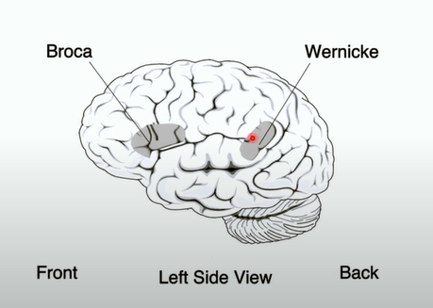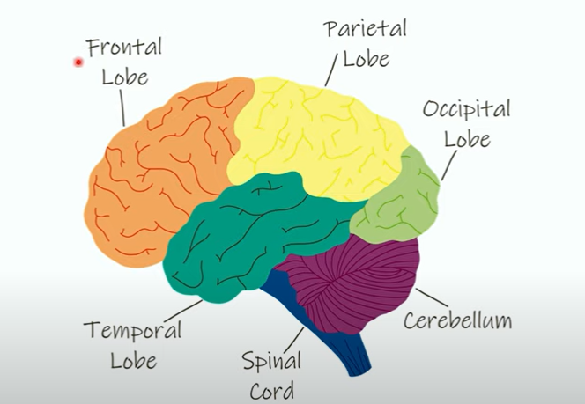

Based on this, we can see that the Broca's area is in the Frontal lobe and the Wernicke's area is in the Temporal Lobe

What do these areas do?
Broca's area: Responsible for sentence formation, initiating speech, and motor control of spoken language. Overall role: controlling speech output
Wernicke's area: Responsible for understanding spoken language and planning use of words. Overall role: comprehension.
Arcuate Fasciculus: Connects the Broca's and Wernicke's areas.

Types of Aphasia:
1. Nonfluent Aphasia: Lesion to Broca's area
- Can understand very well
- Poor speech, writing, and grammar
- Poor naming and repeating of what they hear
2. Fluent Aphasia: Lesion to Wernicke's area
- Can speak very well
- Poor comprehension of what they hear and see.
- Can have paraphasias (substitute one word for another)
3. Global Aphasia (VERY SEVERE): Lesion to both Broca's and Wernicke's area
- Poor speech, and comprehension
- Poor naming and repeating of what they hear
- Cannot read or write
4. Conduction Aphasia: Lesion at Arcuate Fasciculus
- Can understand very well
- Can speak very well
- Poor naming and repeating of what they hear
- Can recognize their mistakes and try to correct them
5. Transcortical Aphasia:
- Sensory: Lesion around (but not in) Wernicke's area
  - Can speak very well
  - Poor comprehension
  - Repeats fluently
- Motor: Lesion around (but not in) Broca's area
  - Non-fluent speech
  - Can understand very well
  - Repeats fluently
  - Poor naming
- Mixed: Lesion around (but not in) Wernicke's, and Broca's area
  - Poor fluent speech
  - Poor understanding
  - Repeats fluently
  - Poor naming
6. Anomia: Lesion at Angular Gyrus
- Can understand very well
- Can speak very well
- Can repeating of what they hear
- Poor naming

Summary of the types of Aphasia:
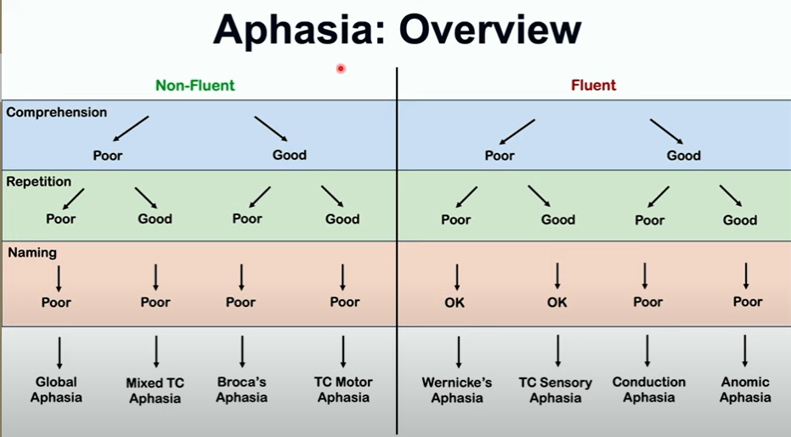

Aphasia Video 2 [https://www.youtube.com/watch?v=4el8c288aNY]:

What is Aphasia?
Aphasia is a communicative disorder that hinders a person's ability to communicate and/or comprehend. Aphasia usually resolves completely if it is caused by nutritional reasons, but for those who got Aphasia due to a stroke or other issues, they can improve, but will most likely not be able to "get rid" of or be completely cured of the disorder.

At any point in time, about 2 million people in the United States will be impacted by some form of Aphasia. Aphasia can be a symptom for other mental disorders such as Parkinson's disorder.

Progressive Aphasia: The symptoms of Aphasia become more and more powerful with time. This can be because our cognitive abilities usually change (mostly go down) as we age.

Careful when diagnosing Aphasia! Just because someone has one symptom of Aphasia, it doesn't necessarily mean that they have the disorder. Being able to diagnose a stroke at an earlier stage can help treat it faster, which can help prevent or lessen the impact of Aphasia. People who have had severe Covid, might also have Aphasia, while those with milder Covid might have trouble remembering some words at times. However, people get better as time passes, after being cured of the disorder.

Symptoms:
- Inability to speak in full sentences
- Talking in gibberish
- Word salad: they say the words correctly, but in a nonsensical order
- Sudden inability to do simple mental math (where they used to be able to do it ealier, but can suddenly not do it anymore).
- Constantly losing your train of thought.
- Completely mislabelling something (like calling a dog a bird, etc.).
- Inability to understand spoken or written language.
- Consistent brain fog

What to do if you experience any of these symptoms?
1. Most of these symptoms can occur separately, due to stress and can usually be very temporary. So to figure out if this is the case, use a method like breathe in- breathe out to calm yourself down and decrease stress.
2. Reflect on your state: How severe or significant are the symptoms? Did they occur suddenly or were they always there?
3. Assess the risk/probability of you having the disorder, based on your analysis from step 2.
4. See a doctor and discuss with them all the problems you are experiencing and report any injuries to the head that might have been a cause or trigger to this

How to prevent or decrease your chances of Aphasia?
- Make sure to eat a balanced and nutritious diet
- Drink a lot of whatever to flush out toxins (which includes things that can slow down cognitive processing)
- Get adequate (quality) sleep
- Engage in activities [this includes playing games like chess, having hobbies like gardening, talking and socializing with other people, etc.] that stimulate the brain (which can slow down the depletion of your cognitive abilities)
- Try to manage stress as well as possible
- Be mindful of alcohol consumption, since alcohol detox can cause peoples blood pressure to go up, and increases their risk of stroke, which can in turn cause Aphasia

Remember! Just because you think you have one symptom or you are blanking out on a word, doesn't mean you have Aphasia, but if you think you are experiencing symptoms, see a doctor as soon as possible, to prevent the disorder from getting worse or being ignored.

Aphasia Video 3 [https://www.youtube.com/watch?v=kGaZuPnIntQ]:

Summary and reflection on this video:
This video was from the UK Stroke Assembly, where different people with Aphasia share their experiences.
1. Bill Lindsay, a person who is living with Aphasia caused by a stroke explains how Aphasia changed his life. This is what I learned from his talk and his experience:
- Life can change very quickly without much of a warning for people who have strokes or tumors, who start developing Aphasia. This can be very traumatizing for them.
- Being unable to express themselves and communicate like they used to be able to, can be very frustrating and stress inducing for people suffering from Aphasia
- To be honest, I really respect Mr. Lindsay admires his outlook on life, because now, he mentors and helps people with Aphasia, to help navigate life, treatment, and support in general. He not only dealt with his situation, but also bounced back and is helping others who are in a similar situation, which is very respectable.
2. Stella Cairns, also a stroke victim with Aphasia shares her experience. This is what I learned from her experience:
- Stella has a hard time understanding words, and even though in most cases, she can communicate properly, her speech is a bit fragmented and she pauses in between words when talking. She shared that sometimes she knows exactly what she wants to say, but has a hard time putting it into words, which is very frustrating for her (understandably so)
- She carries a card wherever she goes to convey to people that she has Aphasia, and she wants to raise awareness about what it is, so that they can understand and empathize.
- She sometimes has trouble pronouncing words. For instance, during the talk, she was trying to say the word "positive," but instead she was only able to say "potisive," even after multiple attempts.
- Despite all of this, Stella keeps a smile on her face, laughs, and likes to make others laugh, which is very impressive, and in a way motivating to look at, because in spite of facing all these challenges, she is able to stay strong, be happy, and make others happy.
3. Paul Hodson, a stroke victim with Aphasia. This is what I learned from his talk and his experience:
- Paul said that he had a very bad smoking and drinking problem, and he had really unhealthy eating habits, which he believes are the reason for his stroke, and thus his Aphasia.
- Paul did speech therapy for a bit to help improve his case, and now, he helps others as a speech and physio-therapist, and is a part of a "Speakability Group"
- Paul has a hard time communicating, because he forgets words while speaking, and has a hard time comprehending, hearing numbers, or hearing months. He usually needs to ask people to repeat and try and read their lips to understand.
- Paul can only read about 6 pages at a time, and he can only read in absolute silence, due to his Aphasia.
- At the time of the diagnosis, Paul was only able to communicate with a yes or no, and he has improved tremendously to a point where he was able to present about his experience.
- Paul is very optimistic and looks at the progress he has made since the start of his diagnosis to now, rather than lamenting about the loss, which I think is a great mentality to move ahead and move on, rather than live in the past, which does no good. This however, is easier said than done, and I have no experience or right to be saying this, but all I can do is be proud of Paul's "upwards and onwards" mentality, and hope that anyone else in his shoes has such an outlook of hope!

Overall reflection:
To be honest, I think I learned the most from this video, just because I could understand the day-to-day problems that people with Aphasia face. I could see what a day in their life is like, and understand how frustrating it could be when they know what they want to say, but cannot express themselves as they wish to. I would say my respect for those living with Aphasia increased by many folds just by watching them talk about their experience, how they cope with it, and how hopeful and optimistic they are. Despite their life taking a 180-degree turn at a very unexpected time, they are very resilient and continue to keep on trying and are now helping other people, which is very admirable. I am very happy that I am a part of this VIP team, where I can help make the lives of those with Aphasia, at least a little better than how they are now, by helping out with our project.

